**Donald Maxwell (1877-1936)**

Enlisted in Royal Naval Volunteer Reserve and posted to North Sea Patrol at Sheerness during WW1. Post war, lived in Borstal, near Rochester.

It chanced that my train ran a little beyond the platform in the direction of Faversham. The time was evening. Strange lights and shadows glancing across the vapour-laden brickfields gave a curious Eastern glamour to the landscape. Suddenly a shaft of gold lit up the distance, and in a moment of time I beheld a city, four-square, with ramparts, gates, and towers. Its architecture was Babylonian or Assyrian. It stood by the waters of Milton Creek, and, because of the familiar sailing barges at its quays, I could see that it was no mirage. Then the sunlight failed. The city vanished, and the train steamed back into the station.

Maxwell’s description of the giant paper pulp stacks at Sittingbourne Papermill. _*Unknown Kent_*, 1921.

Image text: “Its Architecture was Babylonian or Assyrian.”

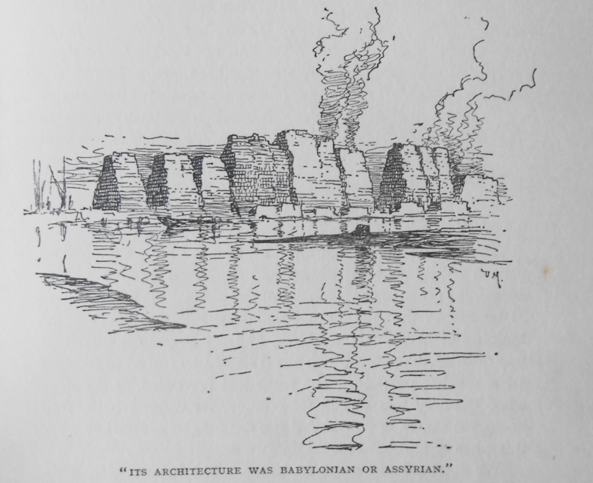

Image text: “The Nearer East – A fantasy of Bluebell Hill.”

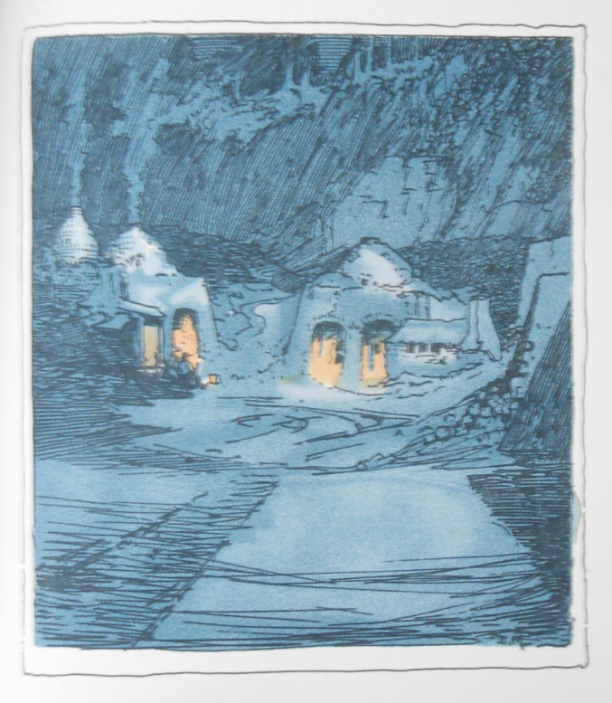

**Article – Babylon, Kent**

Paul Tritton claims that Maxwell ‘did more than any other to inspire his and subsequent generations to explore the Kentish landscape, and view familiar places in a new light.’ His praise is fully justified, but Maxwell is now far less well-known than he deserves, and his vision of landscape is yet to be fully appreciated. Tritton noted that Maxwell saw form and beauty in the ‘commonplace’ and what others would regard as ‘eyesores’. Sadly, most people will still regard as carbuncles the quarries, industries and sites of dereliction that Maxwell eulogised and lovingly illustrated alongside the quaint and the picturesque.

Maxwell used his writing and illustration to infuse the industrial and everyday with a sense of the exotic or the magical. His experience of the Middle East provided him with the ability to see Babylonian structures in pyramids of paper pulp. One whole chapter of _*Unknown Kent_* is devoted to ‘The Land of Cement’ a landscape that many will regard as scarred, to be filled today, at best, with a shopping complex, or become overgrown. Maxwell gloried in the sights and sounds of the cement kilns, especially see at night with ‘Dantesque effects of lurid light when the stokers throw open the furnace doors and chequered light appears on the drifting smoke.’ - there are echoes of earlier artists work, of de Loutherbourg’s _*Coalbrookdale by Night_* (1801) and Joseph Wright of Derby’s _*An Iron Forge_* (1772), in his illustrations. Other ‘eyesores’ were glorified and not just the redundant with their glamour of rust and ruin, but the ‘new’, although Maxwell admits ‘the only people who are likely to see beauty in gasometers and sublimity in chimneys are those very people who are building the new world’; again echoing the union of arts and science during the British Enlightenment.

‘The Haunted Battleship’ (_*The Enchanted Road*_) is an epic description of the demolition of the _*Conqueror_* by commercial shipbreakers at Upnor on the Medway. The ship saw service at Jutland, but the hulk was, when Maxwell visited, being taken apart bit by bit to make ‘razor blades and mowing machines.’ His drawing and description provide dignity to the process. In the ruined wardroom ‘[v]istas of woodland landscape appeared through rents in the steel walls, an eerie compensation for the absence of pictorial decoration.’

Older, abandoned sites of industry also attracted Maxwell’s attention. In _*The Enchanted Road*_ his chapter ‘The Valley of Dreams’ describes a landscape where ‘geography gets lost, where geology is suspended, and where even the laws of gravity are slightly modified’. This ‘valley enchanted’ is no natural phenomenon, but the site of a string of rag stone quarries dating back perhaps to Roman times, now ameliorated by the growth of vegetation. A similar treatment is provided for the Elizabethan iron foundry landscape of the Weald.

Maxwell does, however, provide his fair share of the charming, quaint and the curious, for example his excursion to Colling to visit the ‘lozenge’ tombstones, the model for opening chapter of [_*Great Expectations_*](/dickens/great-expectations-curated-walk)*.*

**Article Peter Vujakovic**

**Bibliography**

Maxwell, Donald. [_*Unknown Kent_*.](<https://ia902700.us.archive.org/28/items/unknownkent00maxw/unknownkent00maxw.pdf>

) London: John Lane, The Bodley Head Limited, 1921.

--. _*The Enchanted Road_.* London: Methuen & Co, 1927.

Tritton, Paul*.* [*_Donald Maxwell’s Valley of Dreams_*.])<https://web.archive.org/web/20110901031521/http://valleyconservation.org.uk/donald_maxwell.htm>) Undated. (accessed 28-11-2020).

Charles, Jeffrey. ‘The Sailors: Amateur British & Irish Yachtsmen Before World War One - Donald Maxwell, 14 April 1877–25 July 1936’. [‘Small Craft’]( <http://www.smallcraft.net/research/the_sailors/donald_maxwell/>) web site, 2014. (accessed 28-11-2020).